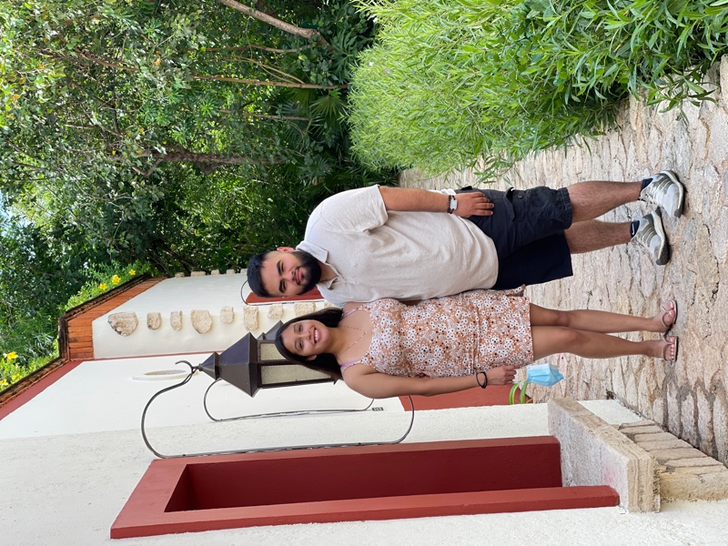My name is Cristian Lara, and I am a junior. I Speak English and Spanish. My pronouns are he/him/his. I’m majoring in Computer science with a double major in Mathematics. With my career I haven’t completely decided where I want to go with it. This is my first semester/year where I would be taking more advanced CS classes. My first two years I focused on mainly my mathematics classes and a few intro classes into CS. So far, I have liked website development the most, but hopefully this year I get exposed to more. I’m in CSC4500 to learn more about how the data is stored. I feel like all my other classes focused more on front end and this would focus more on back-end. One of my biggest non career goals is to lose weight. By the end of the semester, I want to aim to be 20 pounds lighter. I’m not part of any organization.

Other Things about me:

I’m not a picture person. This is the latest picture of me. That’s my girlfriend (3 years).

I was born and raised in Elgin, IL. I consider myself close with my family. When out of school we would all usually try to have dinner together, which I think was very cool. I have two younger sisters (12,17) and one brother (27). I have a few step siblings, but I am not as close to them as all of them have their own families. I do see them in get together, and one out of the three visits us every Sunday. I picked AU for the same reason that it will let me stay close to my family. Also, the scholarships offered brought my cost down by a lot. When picking my school, I was between Western Illinois and AU. Both at similar prices (I was going to Dorm in at WIU), but I visited WIU, and I hated the smell of the school. The dorms had a smell of farm and I didn’t like it.

My favorite season is winter. That is because I hate the heat. I can’t handle heat. If I could set the A/C temperature in the house I would have it at 66/68 degrees every day.

My favorite drink is horchata. Alcoholic drinks I’m not 21 yet (6 more months), but legally I have had drinks in Mexico. I haven’t tried much yet, but so far, I have liked Frozen margheritas, and Paloma/ tequila sunrise cocktails. I’ll see what else I try here when I turn 21.

The coolest place I have been would either be Sedona, Az. I loved the nature here, and the views are just amazing. Or Playa De Carmen. I visited Xcaret and everything was just amazing. From the service all the way to the food and parks they offer. I do want to visit other places then Mexico for sure.